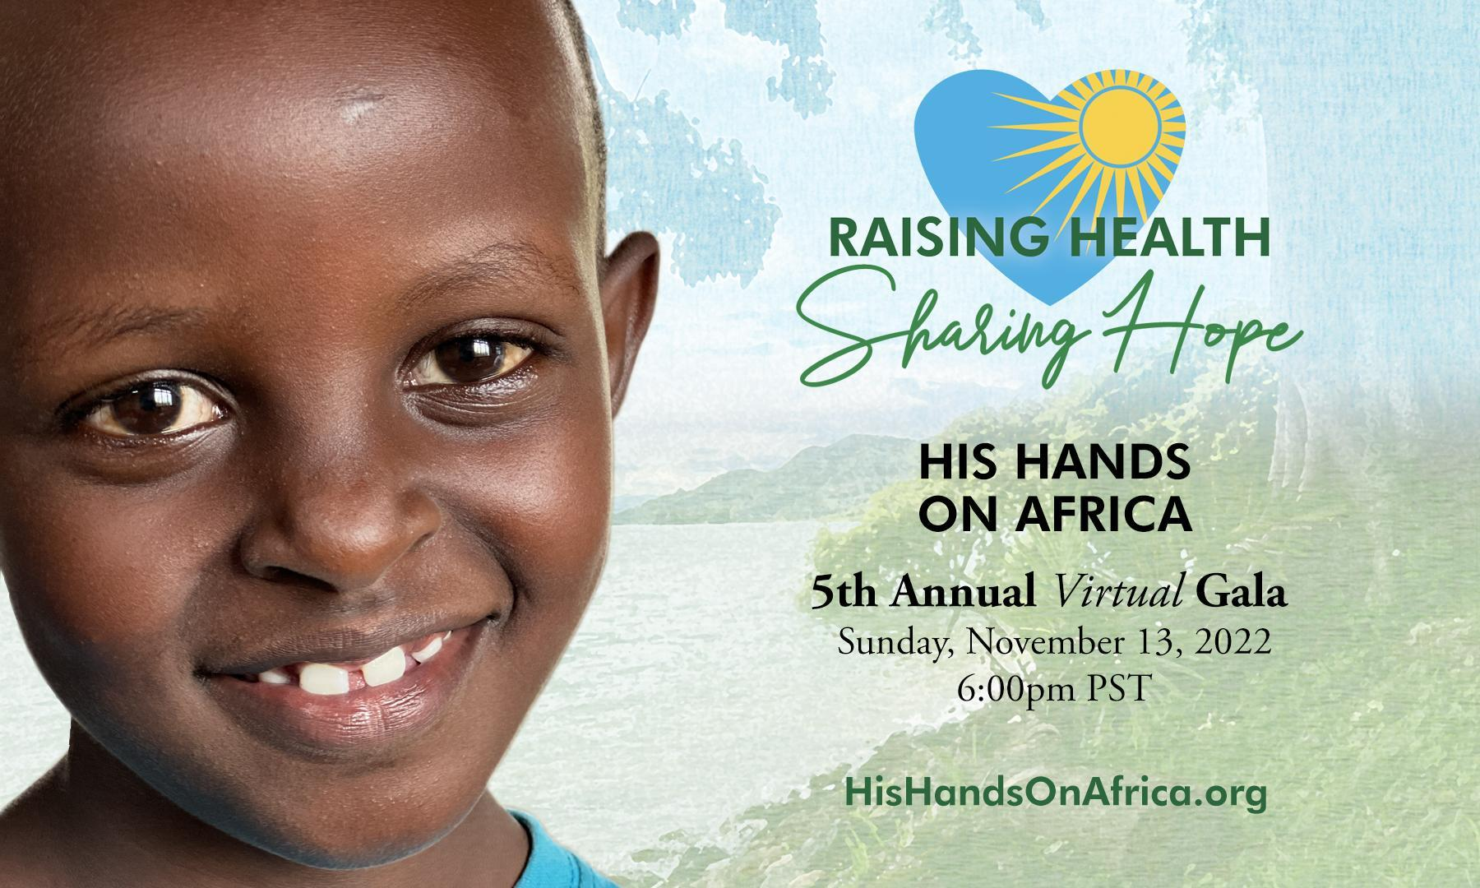

Hi (NAME),

I hope all is well for you. I think you will be interested in this nonprofit ministry called His Hands on Africa, that is making an incredible difference in Africa. They have a very unique mission, one that is desperately needed in Rwanda. I want you to know more about it because I know your heart - to make the Lord known and to make an impact for His kingdom.

HHOA is a medical mission, specifically dentistry. In a country of 13.6 million, there are currently 69 Rwandan dentists. That’s 1 dentist for every 197,000 people. As Americans, we can’t even imagine that - in comparison, we have 1 dentist for every 1642 people.

In Rwanda, people rarely, if ever get the opportunity to see a dentist and they suffer for it. Poor oral health significantly leads to failing overall health, including heart attacks, strokes, and other life-threatening illness.

His Hands on Africa is bringing life-changing and life-saving dental care to Rwanda. They are shaping the dental system and raising levels of health. They are sharing the hope of Jesus.

Please join me at His Hands On Africa’s Virtual Fundraising Gala on Sunday, November 13, 2022. It’s no cost to register. And I promise you will be stirred and inspired as you learn more.

Blessings,
(YOUR NAME)
REGISTER HERE

